|  |  |  |  |  |  |
| --- | --- | --- | --- | --- | --- |
| Date | 7-Dec-22 | | | Tester Name | Mayuri Patel |
| Environment | Penfax - Test | | | Login used |  |
| Operating System | Select OS | Version: | Update: | | |
| Software Used | Select Software | Version: | Update: | | |
| Select Software | Version: | Update: | | |
| Release version | 22.4.1 | | | | |
| Title |  | | | | |
| Test Type | Regression | | | | |
| Test Scenario | annual ROR - combined funds, PEPP and VPB (deposits/withdrawals - fee, reversals, contributions, withdrawals and transfers) | | | | |
|  |  | | | | |
| Expected Results |  | | | | |
| Pass/Fail | Pass | | | JIRA# | N/A |

Describe your steps with screenshots:

1. For PEPP- Combine Fund

Search a PEPP Active member that has combined fund and has contribution

Open that member profile

Make sure of the fund

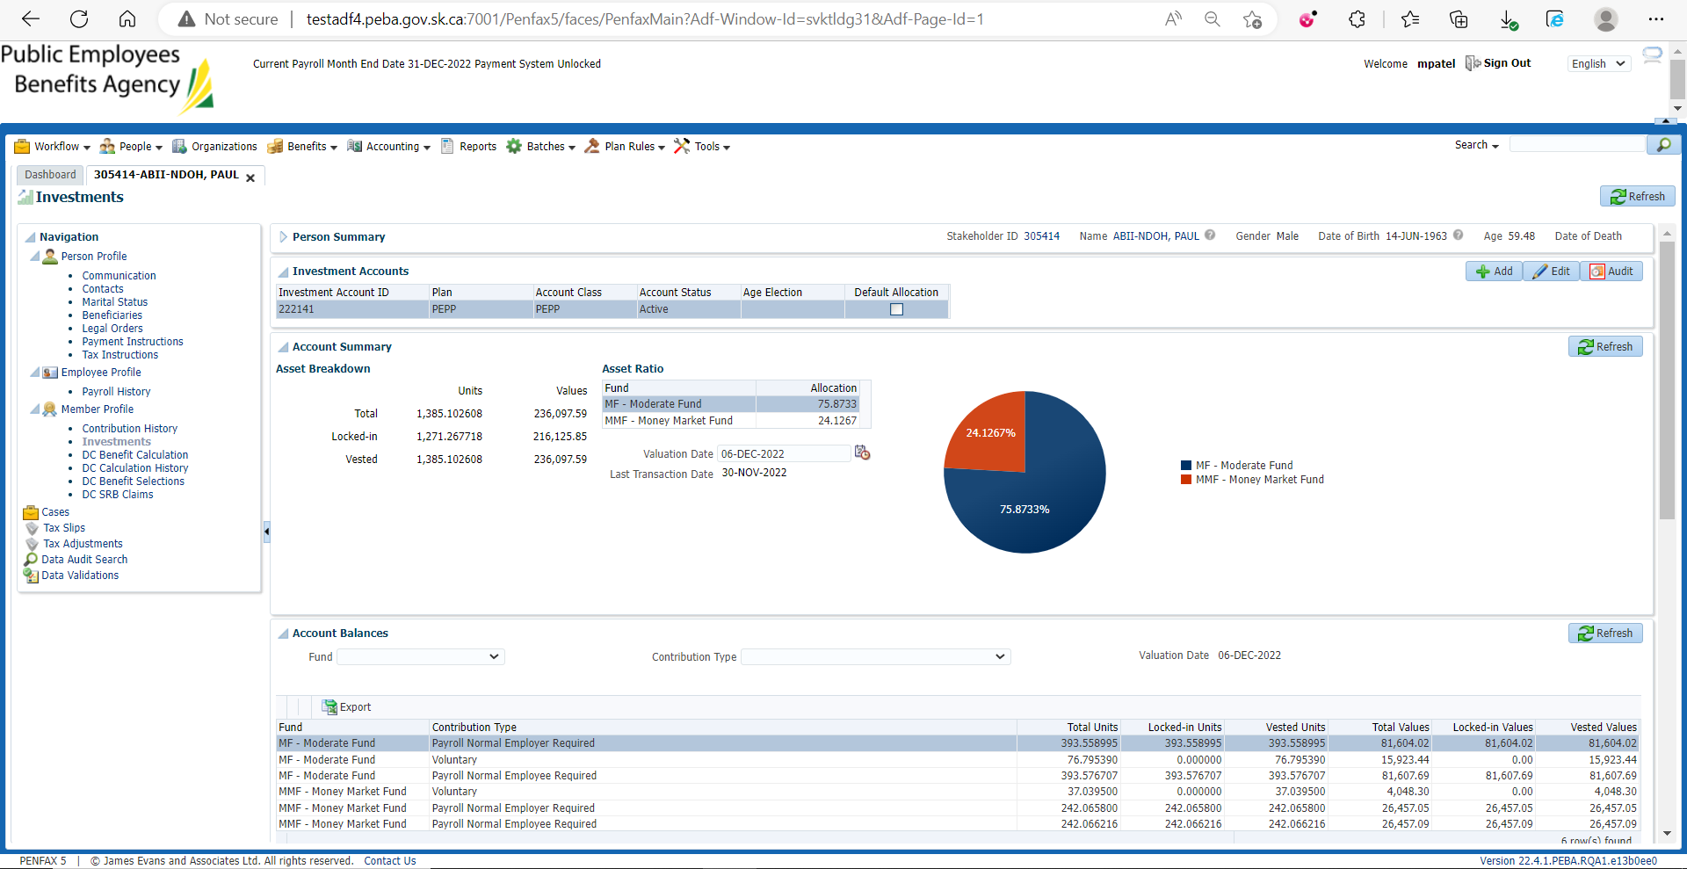

Make sure of contribution

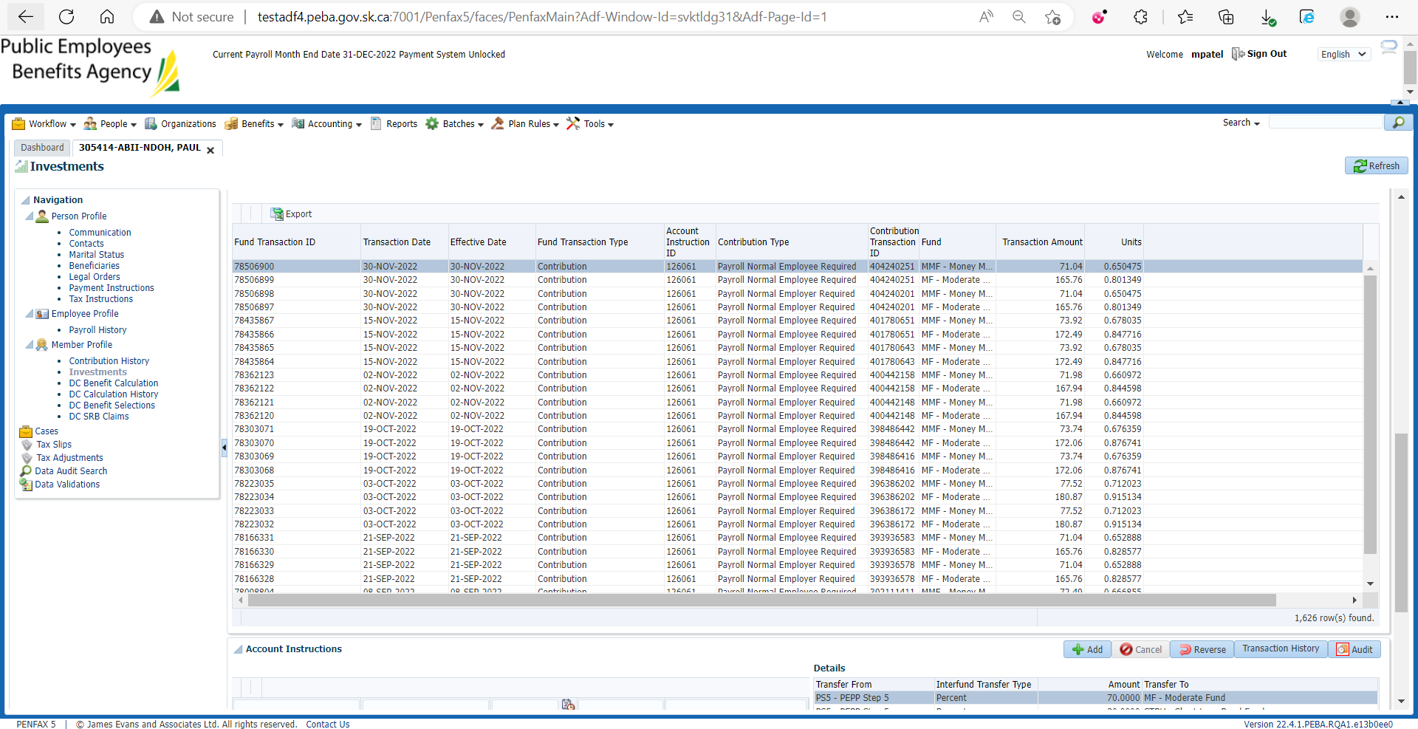

In Account Performance enter relevant details and search

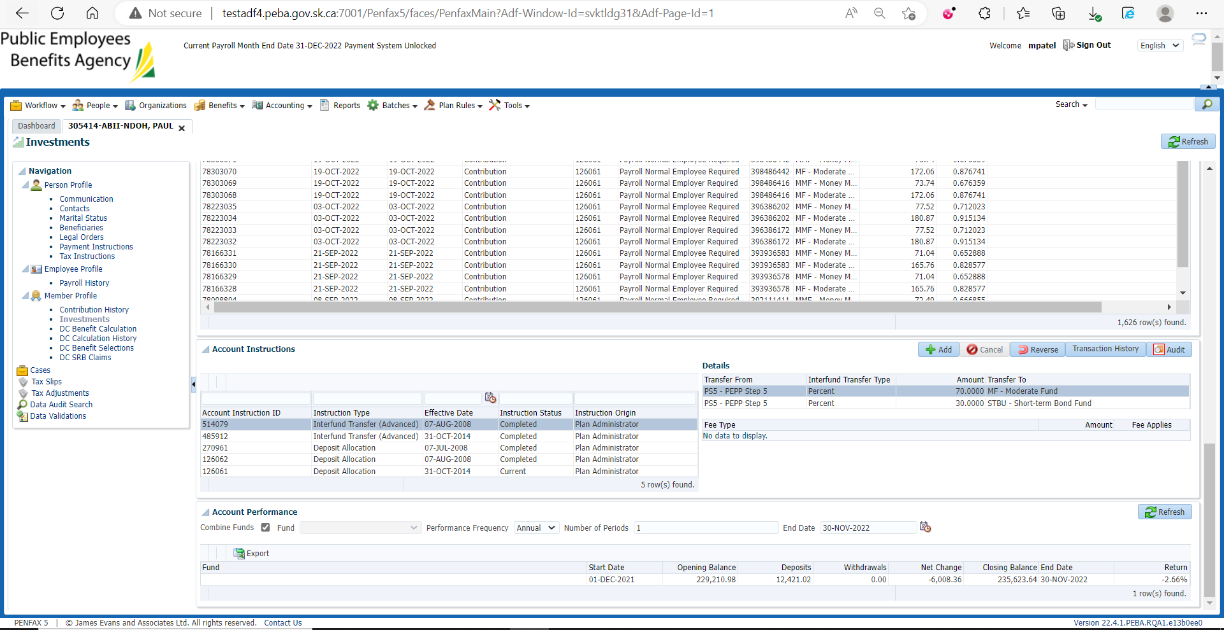

In the spreadsheet for ROR paste the exported file from pen fax and ensure 1-year ROR is calculated properly

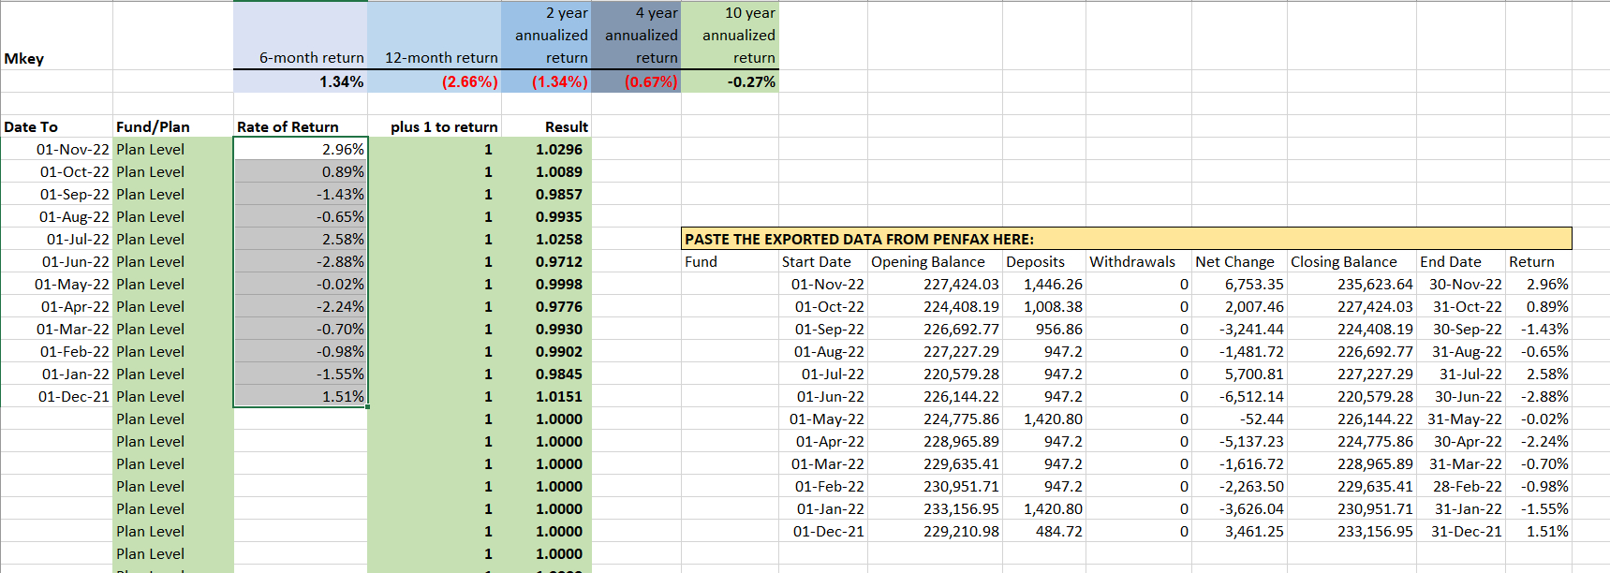

1. For VPB – Combine Fund

Search a VPB Active member that has Combined fund and has scheduled withdrawal

Open that member profile

Make sure of the fund

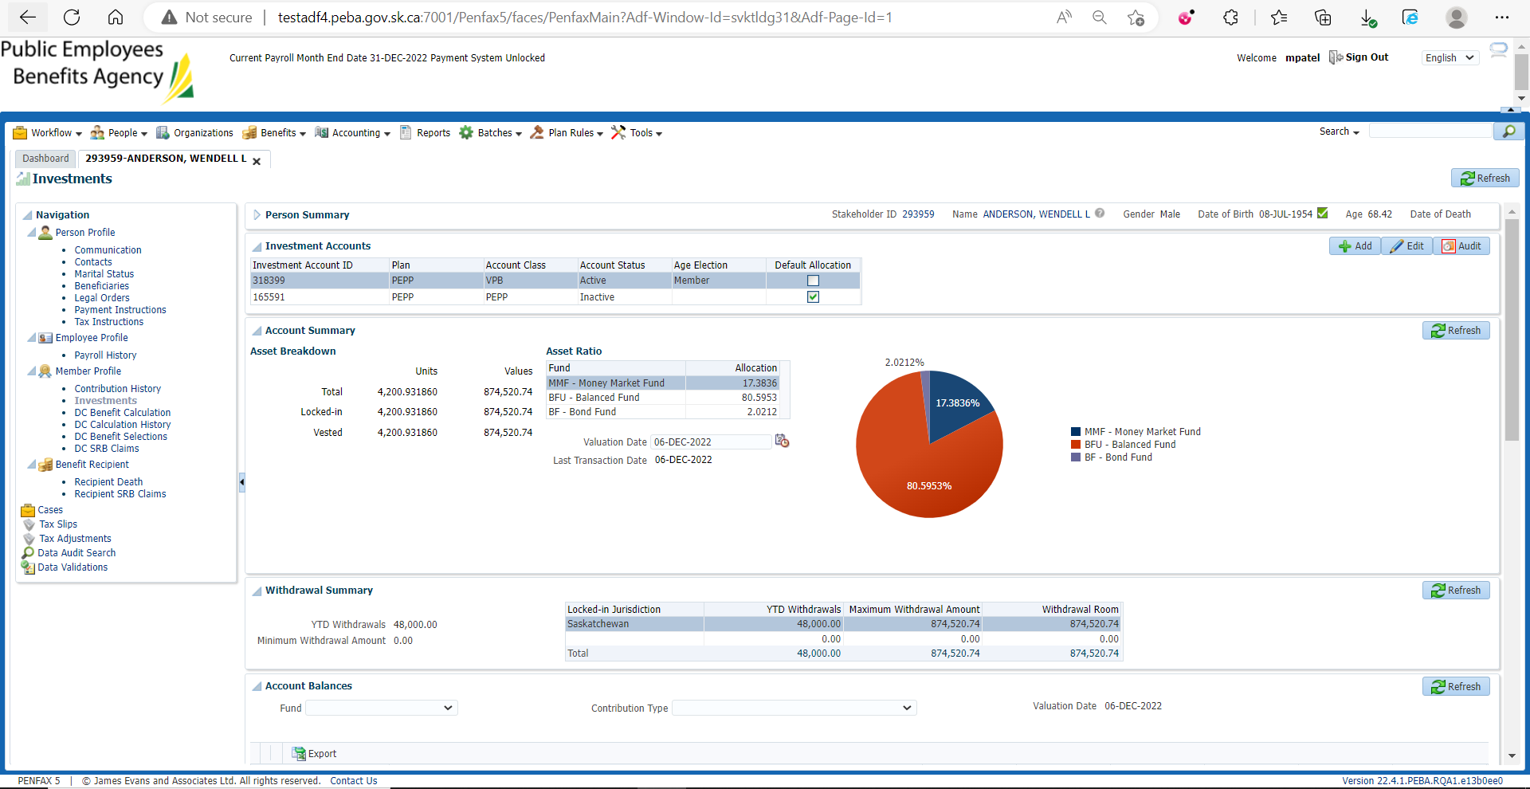

Make sure of the Scheduled Withdrawal

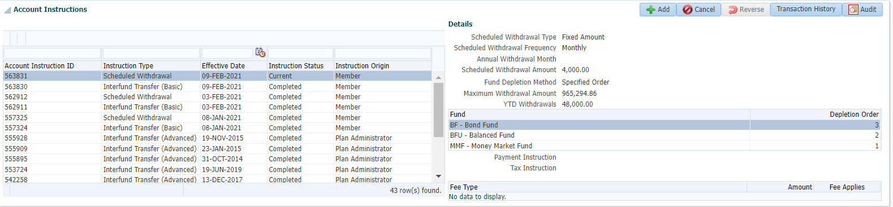

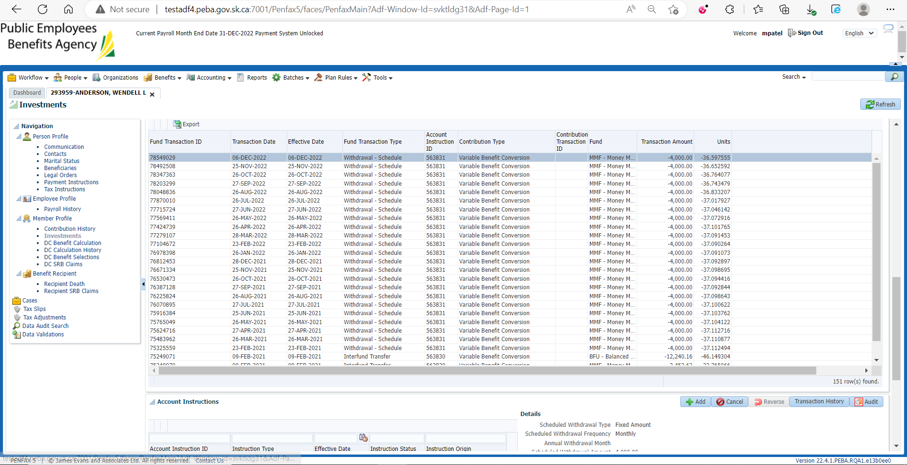

In Account Performance enter relevant details and search

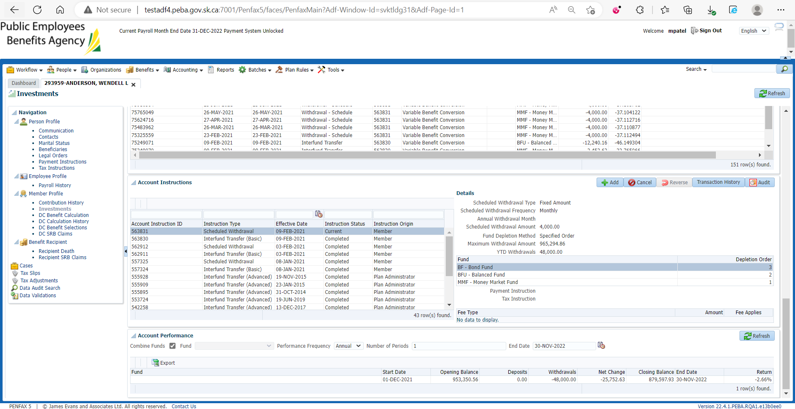

In the spreadsheet for ROR paste the exported file from pen fax and ensure 1-year ROR is calculated properly

